Biology 1002: R Assignment
Part I Questions:
- > library(dplyr)
- > MoosePopulation <- read.csv("C:/Users/trist/Downloads/MoosePopulation.csv")
> View(MoosePopulation)
- > moose_clean <- na.omit(MoosePopulation)

- > moose_sel <- select(moose_clean, Ecoregion, Year, Area, Estimated_Moose_Pop)

- a) > year_min <- min(moose_sel$Year) year_min = 1904
b) > year_max <- max(moose_sel$Estimated_Moose_Pop) year_max = 41250

- > moosedata2 <- mutate(moose_sel, MooseDensity = Estimated_Moose_Pop / Area)

- > plot(moosedata2$Year, moosedata2$MooseDensity, xlab = "year", ylab = "Moose per sq km", main = "Moose density in Newfoundland ecoregions over time")
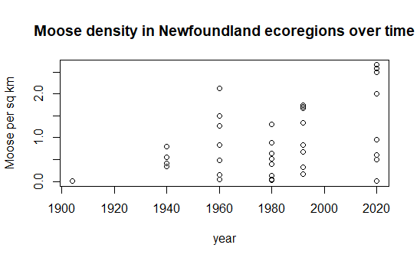

- a.) > moose_west <- filter(moosedata2, Ecoregion == "Western_Forests")

b.) > plot(type = "l", moose_west$Year, moose_west$MooseDensity, xlab = "year", ylab = "Moose per sq km", main = "Moose density in Newfoundland's Western Forests over time")
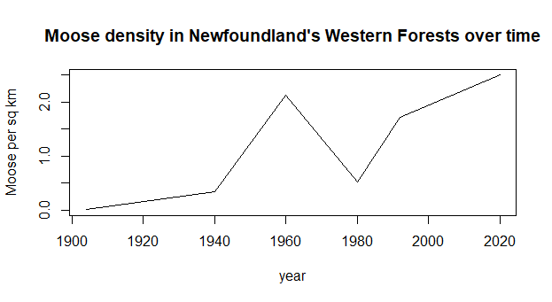

- a.) > moose_2020 <- filter(moosedata2, Year == "2020")
b.) > moose_2020_high <- filter(moose_2020, MooseDensity > 2.0)
c.) > moose_2020_high_byD <- arrange(moose_2020_high, desc(MooseDensity))

- moosefinal <- moosedata2 %>% filter(Year == 2020) %>% filter(MooseDensity > 2.0) %>% arrange(desc(MooseDensity)) %>% print()
Ecoregion Year
1 Northern_Peninsula_Forests 2020
2 North_Shore_Forests 2020
3 Western_Forests 2020
4 Central_Forests 2020
Area Estimated_Moose_Pop
1 12000 32000
2 8400 21740
3 6800 17000
4 20500 41250
MooseDensity
1 2.666667
2 2.588095
3 2.500000
4 2.012195

Part II Questions:
- a.) saplings <- read.csv("C:/Users/trist/Downloads/SaplingStudy.csv")
b.) > sap_clean <- na.omit(saplings)

- a.) >sap_reg_browse <- sap_clean %>% group_by(Ecoregion) %>% summarize(AverageBrowsing = mean(BrowsingScore))
> print(sap_reg_browse)
Ecoregion AverageBrowsing
<chr> <dbl>
1 Avalon_Forests 2
2 Central_Forests 4
3 EasternHyperOceanicBarr… 2.4
4 Long_Range_Barrens 2.6
5 Maritime_Barrens 1.83
6 North_Shore_Forests 4.38
7 Northern_Peninsula_Fore… 4.57
8 StraitOfBelleIsleBarrens 1
9 Western_Forests 4.5

b.) avg_browsing_reg <- arrange(sap_reg_browse, desc(AverageBrowsing))
# Northern Peninsula Forests have the highest Average Browsing, while Strait Of Bell Isle Barrens had the lowest.

- a.) sap_reg_height <- sap_clean %>% group_by(Ecoregion) %>% summarize(AverageHeight = mean(Height))
print(sap_reg_height)
# A tibble: 9 × 2
Ecoregion AverageHeight
<chr> <dbl>
1 Avalon_Forests 32.4
2 Central_Forests 23.8
3 EasternHyperOceanicBarrens 31.6
4 Long_Range_Barrens 29.9
5 Maritime_Barrens 26.7
6 North_Shore_Forests 22.3
7 Northern_Peninsula_Forests 19.9
8 StraitOfBelleIsleBarrens 25.4
9 Western_Forests 18.9

b.) sap_reg_height_low <- filter(sap_reg_height, AverageHeight < 20 )
> # The Northern Peninsula Forests (19.91429) and Western Forests (18.94000) have the lowest average heights under 20

- a.) > sap_spe_browse <- sap_clean %>% group_by(Species) %>% summarize(AverageBrowsing = mean(BrowsingScore))
> print(sap_spe_browse)
# A tibble: 6 × 2
Species AverageBrowsing
<chr> <dbl>
1 "Alder " 4.25
2 "Balsam_Fir" 3.14
3 "Black_Ash" 5
4 "Black_Spruce" 2.33
5 "White_Birch" 3.14
6 "Willow" 4.31

b.)
> avg_browse_spe <- arrange(sap_spe_browse, desc(AverageBrowsing))
> # Black Ash has the highest average browsing at 5.000000, while Black spruce has the lowest at 2.333333

- fir_reg_browse <- sap_clean %>% filter(Species == "Balsam_Fir") %>% group_by(Ecoregion) %>% summarize(AverageBrowsing = mean(BrowsingScore))

- barplot(fir_reg_browse$AverageBrowsing, names.arg = fir_reg_browse$Ecoregion, xlab = "Ecoregion", ylab = "average browsing intensity", main = "Average Browsing intensity of Balsam Fir per Ecoregion", col = "forestgreen", cex.names = 0.3)
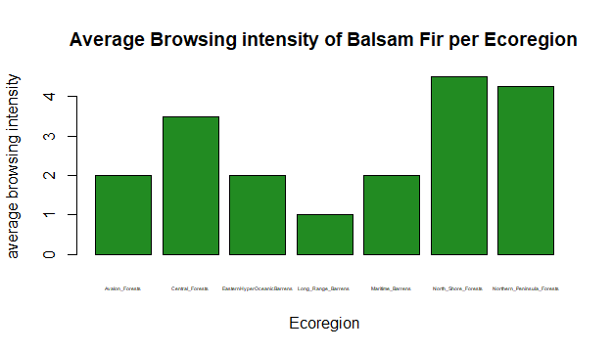
- a.) spruce_reg_browse <- sap_clean %>% filter(Species == "Black_Spruce") %>% group_by(Ecoregion) %>% summarize(AverageBrowsing = mean(BrowsingScore))

b.)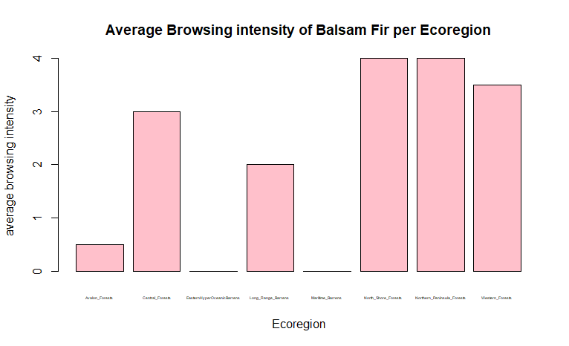
barplot(spruce_reg_browse$AverageBrowsing, names.arg = spruce_reg_browse$Ecoregion, xlab = "Ecoregion", ylab = "average browsing intensity", main = "Average Browsing intensity of Balsam Fir per Ecoregion", col = "pink", cex.names = 0.3)

c.) # Black spruce and Fir differ, as black spruce has the average browsing intensity as 0.0 for two Ecoregions, while the Balsam fir have at least an average browsing intensity of one or more per Ecoregion

- sap_reg_tally <- sap_clean %>% group_by(Ecoregion) %>% tally()
print(sap_reg_tally)
# A tibble: 9 × 2
Ecoregion n
<chr> <int>
1 Avalon_Forests 5
2 Central_Forests 5
3 EasternHyperOceanicBarrens 5
4 Long_Range_Barrens 5
5 Maritime_Barrens 3
6 North_Shore_Forests 8
7 Northern_Peninsula_Forests 7
8 StraitOfBelleIsleBarrens 1
9 Western_Forests 5

- sap_spe_tally <- sap_clean %>% group_by(Species) %>% tally()
- a.) # the Strait Of Belle Isle Barrens were underrepresented, as well as Maritime Barrens. The North Shore Forests were overrepresented. I feel this may be realistic though because of the sheer density of saplings in a forest in comparison to barrens. Alder and Willow are underrepresented

b.) # It is important to recognize bias in ecological datasets to ensure that the data is well rounded, realistic and covers important data from all areas, sample types etc.

Part III Questions:
- a.) moose_2020b <- moose_clean %>% filter(Year == "2020") %>% mutate(MooseDensity = Estimated_Moose_Pop / Area)

b.)moose_sap <- left_join(moose_2020b, sap_clean, by = 'Ecoregion', relationship = "many-to-many")

- > sum_spe_browse <- moose_sap %>% group_by(Species, Ecoregion) %>% summarize(AvgBrowsing = mean(BrowsingScore), AvgDensity = mean(MooseDensity))

- Based on the figure, answer the following questions using 1-2 sentences.
- Is there evidence that supports the researchers’ hypothesis? Do moose show strong preferences at low density and shift to more generalist browsing at higher density? Add a short comment (1-2 sentences) with your answer.
# The hypothesis is supported by the data/figure. At lower moose density the moose browse at a high score for just a few species. At high densities the browsing scores increase, which suggests more competition in feeding and having to select at more of a variety

- Which sapling specie(s) do moose favour the most? Which do they browse the least? Add a short comment (1-2 sentences) with your answer.
# it seems the moose prefer the willow and alder the most. They seem to prever black spruce and black ash the least

- Which sapling species is not shown on the figure and why? Add a short comment (1-2 sentences) with your answer.
#it doesnt appear to me that any species are not shown or missing

24.) collisions2020 <- c(56, 60, 14, 36, 48, 10, 40, 110, 6)
> human_pop <- c(18000, 12000, 4000, 75100, 24000,3500, 32000, 270000, 2300)
> study_sites <- c("North_Shore_Forests","Northern_Peninsula_Forests", "Long_Range_Barrens","Central_Forests","Western_Forests","EasternHyperOceanicBarrens","Maritime_Barrens","Avalon_Forests","StraitOfBelleIsleBarrens")

25.) a.) >moose_coll2 <- moose_coll %>% rename(Ecoregion = study_sites)
b.) >coll_merge <- left_join(moose_2020, moose_coll2, by = "Ecoregion")

26.) a.) >plot(coll_merge$MooseDensity, coll_merge$collisions2020, xlab = "Moose Density (moose/km^2)",ylab = "Moose-Vehicle Collisions (2020)", main = "Moose Density vs Vehicle Collisions (2020)")
b.) #with greater moose population density there are greater moose vehicle collisions. there are a few outliers but not with great significance

27.) >coll_merge_per_capita <- mutate(coll_merge, coll_per_capita = collisions2020 / human_pop)
arrange(coll_merge_per_capita, desc(coll_per_capita))

28.) > plot(coll_merge_per_capita$human_pop, coll_merge_per_capita$coll_per_capita, xlab = "Human Population", ylab = "Moose Collisions per Capita", main = "Moose Collisions per Capita vs Human Population")
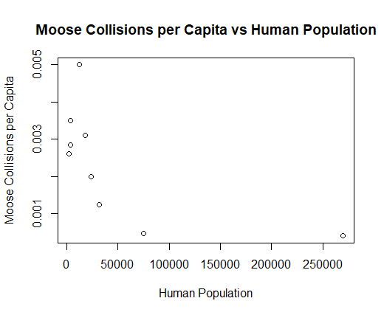

29.) ># with smaller human populations there is a higher risk of moose collisions per capita. When there are higher human population there is less risk of collision per each person

